***TITLE:*** *RENTAL APP*

***ABSTRACT:*** Far From Home”, an Android Mobile Application is a Rental System developed mainly for students, employees and other professionals who are living as PGs or on rent. It will work mainly to book flats or houses on duration of months or year as per the requirements of the User. The sole purpose of this application is to achieve complete transparency between the owner and the tenant in the entire process of renting by removing the role of a middleman – a broker. This will help the owner to get verified tenants and the tenants get a wide range of property options as per their requirements.

**PROJECT SUMMARY:** This report discusses about Far From Home – a House Rental System, an Android Mobile Application which will help students, employees and other professionals who are living as PGs or on rent. It also brings complete transparency between the customer and the owner removing the middlemen.

**PURPOSE:** Many students, employees and other professionals find difficulties in finding house on rent. This is the best platform for of them. Also it is such system which excludes the work of middlemen, i.e. the broker and thus, brings transparency in the process.

**OBJECTIVE:**

The Objectives of the Application are:

1. Let users search for house deals using sorting and filters and also add it to favorites.
2. The application provides list of the house deals.
3. The system provides options to view house deals and to contact owner.
4. Providing a user friendly interface to book a home for rent.
5. Providing a safe and secure payment gateway for user.

**SCOPE:**

The Things it can do:

1. The system provides login/signup facilities to the users.
2. The system provides the members with the option of forgot password and also delete user profile.
3. The system provides options to view house deals and to contact owner.
4. Provides In-App safe and secure payment facility.

**INTERFACE:**

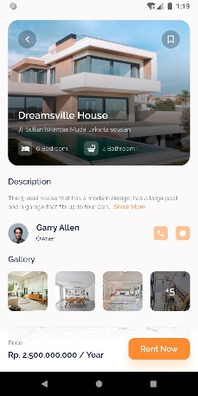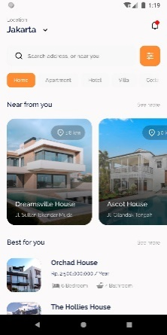

**CONCLUSION:**

Many students, employees and other professionals find difficulties in finding house on rent. We investigated such problems brought up the idea for our project. This is the best platform for of them. Also it is such system which excludes the work of middlemen, i.e. the broker and thus, brings transparency in the process.